Flow Cytometry

Peripheral whole blood samples were collected from each subject at the indicated four time points. The following antibody panel against human markers was used to identify the different B cell populations: CD45 (Pacific Orange) (Invitrogen); CD14 (Alexa Fluor 700), CD20 (Pe-Cy5), IgD (FITC), CD24 (PE) (BD Pharmingen); CD19 (ECD, Beckman-Coulter); CD27 (APC-Cy7, BioLegend); CD38 (Pe-Cy7), CD138 (APC) (BD BioScience). The protocol for staining cell surface antigens is described elsewhere (15). Briefly, two hundred µL of whole blood were added to the listed multicolor staining panel and incubated at room temperature for 15 minutes, followed by lysis of red blood cells (BD FACS Lyse Solution). Events were collected on a LSRII instrument (BD Biosciences, San Jose, CA) and analysis performed using FlowJo™ software (Treestar, Inc version 9.4.11). Naïve B cells were identified as CD19+IgD+CD27-; memory B cells as CD19+IgD-CD27+; transitional B cells as CD19+CD24+CD38+; plasmablasts as CD19+CD27+CD38+ and plasma cells as CD19+CD27+CD38+CD138+.

**Procedure for Staining Cell Surface Antigens:[1]**

1. Aliquot the appropriate volume of antibodies in a 2ml deep well plate according (50uL). Add 200uL of whole blood to each well.
2. Clean edges with swab, if needed.
3. Mix the wells by using a multichannel Pipette or by gentle vortexing (setting < 8).
4. Incubate at RT for 15 minutes.
5. After Incubation add 1.5ml of 1X BD FACSLyse Solution AND mix well by using multichannel Pipette.
6. Incubate for 10 minutes at RT (the cells are fixed at this time point).
7. After Incubation centrifuge the deep well plate at 500 x g for 5 minutes with lid on.
8. Remove supernatant carefully by using vacuum aspirator.
9. Vortex gently and add 1.5 ml PBS w/o Ca++, Mg++ and centrifuge at 500 x g for 5 minutes.
10. Repeat step 8.
11. Re-suspend wells with 250uL PBS and mix well.
12. Transfer the contents of wells to a labeled PPN tubes is a PPN Tube Rack.
13. Store the PPN Tube Rack at 4°C until analysis by Flow cytometer (cover with aluminum foil).

**Compensation Controls:**

* FITC: LIN2: 2.5uL
* Pe: CD3: 1uL
* ECD (=Pe-Texas Red): CD19: 2.5uL
* Pe-Cy5: CD8: 1.5uL
* Pe-Cy7: CD4: 1.5uL
* Pacific Blue: CD4: 1uL
* Pacific Orange (=Qdot 565): CD45: 1.25 ul
* APC: CD16: 1uL
* Alexa F. 700: CD3: 0.5uL
* APC-H7: CD8: 1.75uL (=APC-Cy7)
* Pe-Cy5.5: CD11c: 3uL

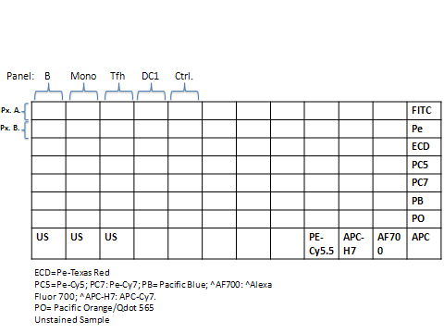 Ctrl=1.25 PO CD45

1.